**Assignment Date: 22-09-2022**

**Name : VARSHINIE SAGARIKAA M.S**

**Reg No :111519106167**

**Maximum Marks: 2Marks**

**Question**

Build a python code by assumming temperature and humidity values using random function .And write a condition to continuously buzz an alarm in case of high temperature.

Program:

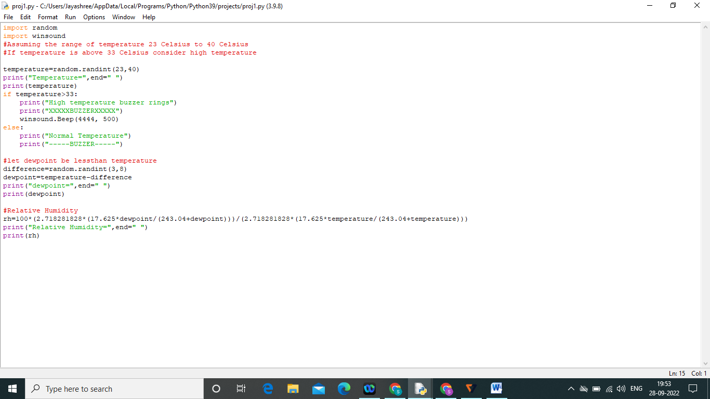

Output:

